Assignment – 1

* Siddhant Jain
* 23517058

Question 1:

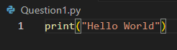

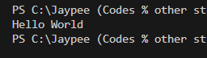

Question 2:

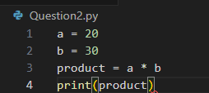

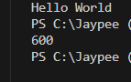

Question 3:

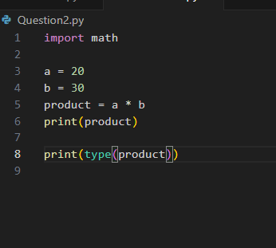

Question 4:

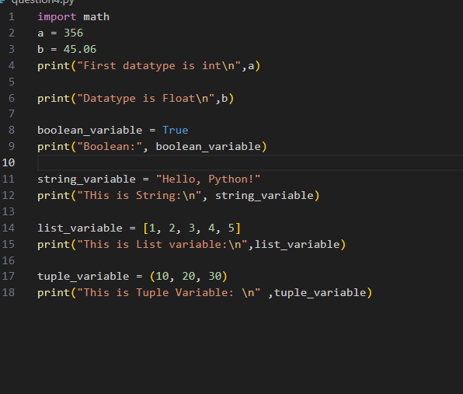

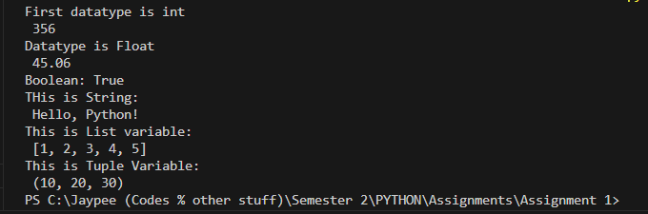

Question 5:

#Arithematic Operator

a = 10

b = 5

print("Addition:", a + b)

print("Subtraction:", a - b)

print("Multiplication:", a \* b)

print("Division:", a / b)

print("Floor Division:", a // b)

print("Modulus:", a % b)

print("Exponentiation:", a \*\* b)

#Comparison Operator:

x = 67

y = 23

print("Not Equal:", x != y)

print("Greater Than:", x > y)

print("Less Than:", x < y)

print("Greater Than or Equal:", x >= y)

#logical Operat

p = True

q = False

print("AND:", p and q)

print("OR", q or p)

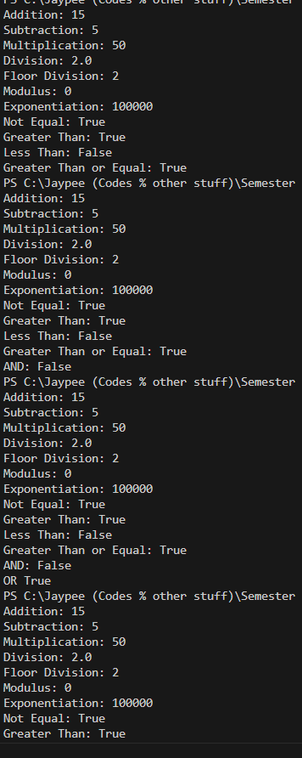

Question 6:

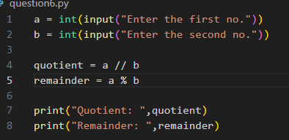

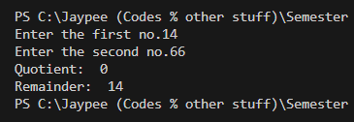

Question 7:

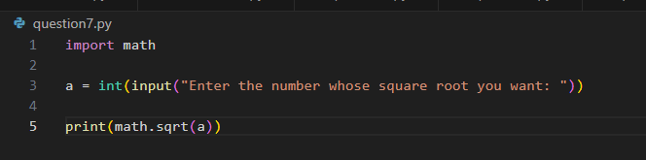

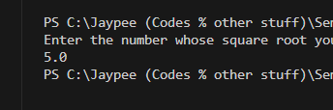

Question 8 :

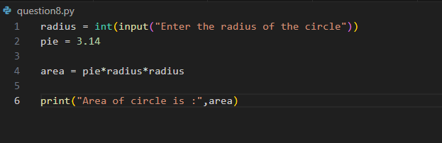

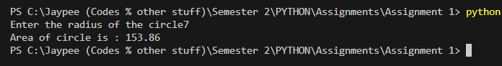

Question 9:

